LITERATURE SURVEY

A literature review surveys books, scholarly articles, and any other sources relevant to a particular issue, area of research, or theory, and by so doing, provides a description, summary, and critical evaluation of these works in relation to the research problem being investigated.

**Problem Identification**

CKD is a condition in which the kidneys are damaged and cannot filter blood as well as they should. Because of this, excess fluid and waste from blood remain in the body and may cause other health problems, such as heart disease and stroke.

# Problem Solution

The purpose of this study was to assess the feasibility of machine learning (ML) in predicting the risk of end-stage kidney disease (ESKD) from patients with chronic kidney disease (CKD). Data were obtained from a longitudinal CKD cohort. Predict variables included patients ’baseline characteristics and routine blood test result.

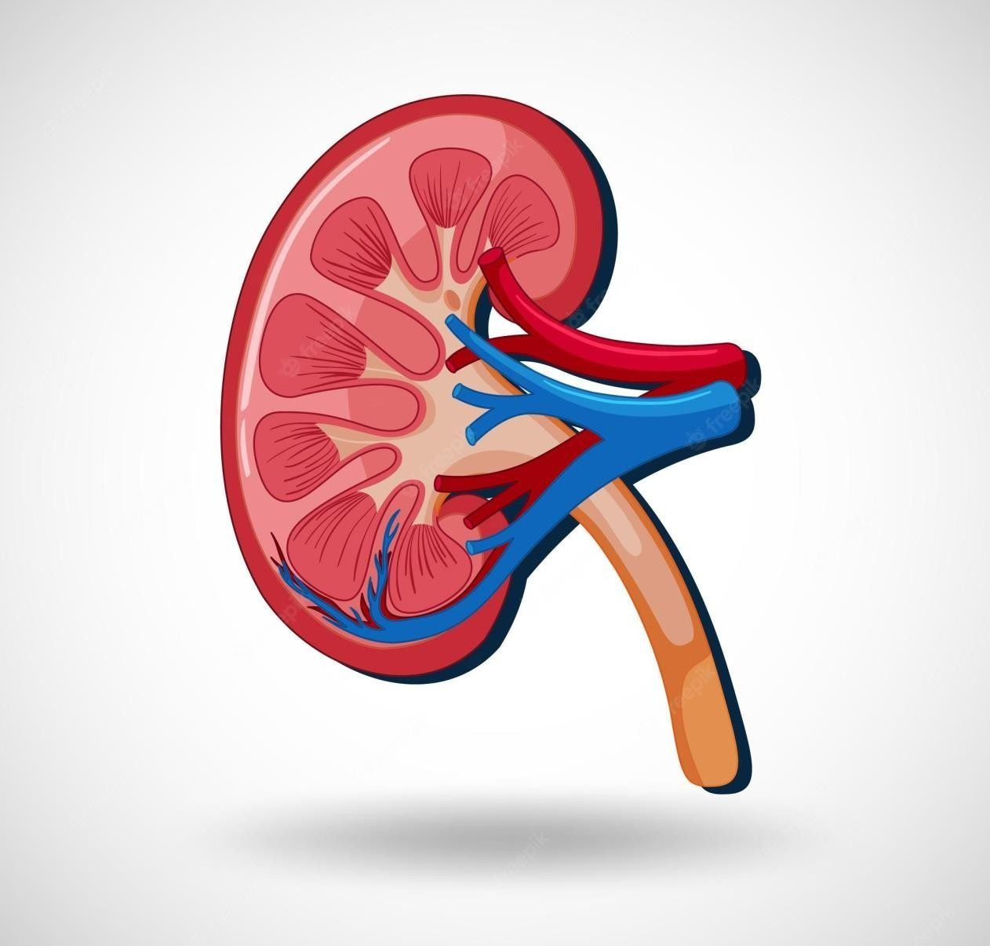

# REFERENCE

[1]“Your Kidneys & How They Work |NIDDK.” [On-line]. Available: [https://www.niddk.nih.gov/health-information/kidney-disease/kidneys-how-](https://www.niddk.nih.gov/health-information/kidney-disease/kidneys-how-theywork%5b2) [theywork[2](https://www.niddk.nih.gov/health-information/kidney-disease/kidneys-how-theywork%5b2)] “Kidney Disease: The Basics,” Aug. 2014. [Online].

Available:https://[www.kidney.org/news/newsroom/factsheets/KidneyDis](http://www.kidney.org/news/newsroom/factsheets/KidneyDis) Cs[3] “Global Facts: About Kidney Disease,” [Online].

Available:https://[www.kidney.org/kidneydisease/global-facts-about-](http://www.kidney.org/kidneydisease/global-facts-about-) kidneydisease/.

# CONCLUSION

Machine learning algorithms while considering the Number of tests or features. We approaches aim by applying Four machine learning classifiers: logistic regression, SVM, Random forest, and gradient boosting on a small dataset of 400 Records. In order to reduce the number of features and remove Redundancy, the association between variables have been Studied. A filter feature selection method has been applied to The remaining and found that there are hemoglobin Albumin, and Specific gravity have the most impact to predict the CDK.